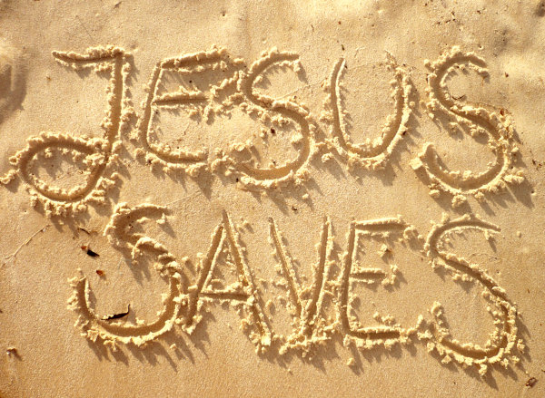

Jesus
is
Saviour

At the heart of the Christian religion is the message that we cannot save ourselves.
The reason why there is pain and suffering in the world is because of sin. Sin is rebellion against God, it is rejecting Him and His love for you, it is not doing what He asks you to and it is doing what He tells you not to. In the Bible we are told that ‘God is Light, and there is absolutely no darkness in Him’. (1 John 1.5). You cannot have light and darkness together at the same time – if you want a relationship with God then you cannot be living in darkness, in sin. The problem is that we are all, deep down, full of darkness. We all sin, we all think and feel and act in ways that break God's heart. So how can we possibly restore our relationship with God?
The Good News – the Gospel – is that God has already acted to restore our relationship with Him. But how has God made things right, why and how does He forgive us? God is perfectly just which means that He cannot let sin go unpunished, but He is also perfectly merciful and loves to forgive us. The most important way Jesus saves us is by what happened on the cross. The crucifixion of Jesus stands at the centre of all history, all time, all of the universe. At the cross God's immovable justice and His unstoppable love meet. What happens at the cross can best be described by the title 'The Divine Exchange.'

What is the problem? Here is the problem, we are all sinners, we cannot be allowed into God's presence because we are unholy. Among other things, sin is a crime that requires a punishment if there is to be any real justice. A price must be paid, there is no way around this. If I go into your house and smash your lamp only one of three things can happen: either I pay for the lamp, you pay for the lamp, or you 'pay for it' by no longer having a lamp; someone has to pay the price. The more expensive the lamp I broke the greater that payment is going to have to be.
Because God is so much greater than us, because God is infinite, the 'payment' required for breaking our relationship with Him is infinite and greater than we could ever afford. This is why we cannot save ourselves – it is just not possible even if we were to, from now on, be completely perfect and do nothing but good.

How can we be brought back into a relationship with God if we cannot pay for our sins? The only answer is for God to pay for it Himself, for God to take the punishment we deserve. This way justice is served and mercy overflows. Think of it like this, it is as if everyone is in debt except Jesus, because we are all in debt we can't help each other out, only Jesus has the credit rating to do that. Only God is perfect, only God is infinite, only God is worthy to pay the price. This is why Jesus Christ came to us: ‘God so loved the world that He gave His One and Only Son, so that everyone who believes in Him will not perish but have eternal life’. (John 3.16).

God came to take our place to pay our way. In order to truly take our place God had to become one of us and experience all that we experience. Jesus is fully God, but He is also fully human – He was born of the virgin girl Mary and was 'made man'. He got hungry just as we do, He got thirsty just as we do, He felt pain and suffering just as we do, He was tempted just as we are, in fact He was like us in every single way except one – He never sinned, He was perfect. Jesus had to become human so that He could truly take our place and pay the price – He knew that only He could be the perfect substitute that we need.
We are told in 2 Corinthians 5.21 that ‘He made the One who did not know sin (Jesus) to be sin for us, so that we might become the righteousness of God in Him.’

The Cross was the 'judgement day' for those who believe. On the cross Jesus takes upon Himself all of our sin, our shame, our darkness, our evil and He becomes our sin. On the cross Jesus becomes the thief, the liar, the murderer, the adulterer, even the paedophile. Whatever we are through sin, that is what He became when He accepted our sin as His own. All of this sin breaks apart the perfect relationship which Jesus had with His Father since before time began – just as our relationship with the Father is broken through sin – and He cried out: ‘My God, My God, why have You forsaken me!?’ (Matthew 27.46). Jesus, having taken our sins, is judged in our place – and He is found guilty, He suffers the death penalty for the wages of sin is death. All of God's just and righteous anger and wrath towards the sins which have destroyed His people and creation is vented on Jesus. Jesus paid the ultimate price and on the cross God Himself died instead of us. Justice was served, God's righteous anger was satisfied: God loved us enough to take our place and make our relationship with Him right. Because Jesus was judged in our place we have no reason to fear judgement and we have no reason to fear condemnation.

‘Much more then, since we have now been declared righteous by His blood [death on the cross], we will be saved through Him from wrath.’ (Romans 5.9 - see also 1 Thess 1.9-10)
Jesus gives us all His good stuff. But what does it mean that we ‘have now been declared righteous’. This is where the 'Divine Exchange' comes in. You see, on the cross when Jesus died He did not just take all of our sin and shame and mess but He gave us instead His holiness, His righteousness, His perfect relationship with the Father. The Bible describes this with the image of a cloak of 'righteousness' or 'holiness' which shows that we are adopted children of God. We don't make the cloak, it is not even ours, it belongs to Jesus – but He takes it off His shoulders and places it on ours when we give Him our dirty and mucky clothes. We are not righteous – we still sin all the time – but because of Jesus taking our place, and we taking His, we are declared righteous and God treats us as if we were His own children. The Father said of Jesus at His Baptism ‘This is my Son, whom I love, I take delight in Him’ (Matthew 3.17) – these are the exact same words God the Father says to us when we are declared righteous and adopted into His family.
But how are we declared righteous? How do we have Jesus place His glorious cloak upon us? Do we have to earn this as if it were a reward or competition? NO! It is something we do not deserve and could never earn. Paul tells us how we are declared righteous in Romans chapter 5 verses 1-2: ‘Therefore, since we have been declared righteous by faith, we have peace with God through our Lord Jesus Christ. We have also obtained access through Him by faith into this grace [freely given gift that we don't deserve and cannot earn] in which we stand, and we rejoice in the hope of the glory of God.’
Belief is the only way. We are declared righteous, we are adopted as Children of God, we receive His love, His mercy, and His grace, we have peace with Him when we believe. We are saved by faith alone, not by good deeds and being nice. As Paul tells us elsewhere: ‘For you are saved by grace through faith, and this is not from yourselves; it is God's gift - not from works so no one can boast.’ (Ephesians 2.8-9)
We are saved by grace alone, through faith alone, in Jesus alone, to the glory of God alone. When we believe in Jesus as God and Lord, and when we repent of our sins because of this and turn to Him as Saviour, we are saved by the overflowing love and mercy of God. If we want to go to heaven we need to believe in Jesus and all that He said and did. Getting baptised will not make us go to heaven. Being a 'good person' will not allow us access to heaven. As Peter said to the crowds not long after Jesus went back to Heaven ‘There is salvation in no one else but Jesus, for there is no other name under heaven given to people, and we must be saved by it.’
What this means for Baptism. This is why your promises are so important at baptism – as parents and godparents you are promising to raise your child in the faith, to teach them day by day, by words and actions, that Jesus is God, Jesus is their Lord, and that they are saved by Jesus through their faith in Him.
This is why you are asked and say in the service of baptism:

Will you pray for him/her, draw him/her by your example into the community of faith and walk with him/her in the way of Christ?
With the help of God, we will.
Will you care for him/her, and help him/her to take his/her place within the life and worship of Christ’s Church?
With the help of God, we will.

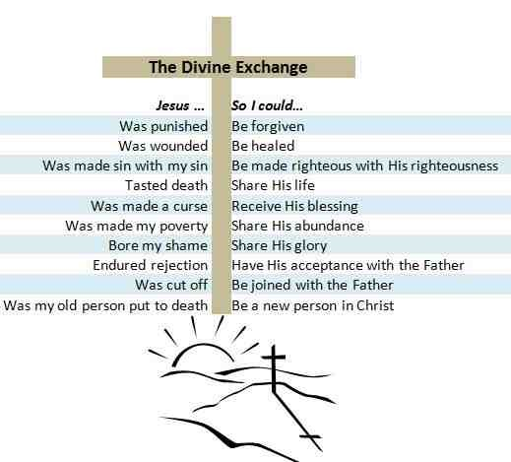
These are serious vows, and the reason that we have been doing this course is so that you are aware of what they mean. In the service you say on behalf of the child that they will ‘turn to Christ as Saviour’ and that they will ‘come to Christ the way, the truth, and the life’. You make these vows in their place because you promise, with the help of God Almighty, to bring them up in the faith – something which requires that you yourselves believe it. Next week will be our final session and we will look at the service of baptism itself and also the possibility of a dedication service if you are not comfortable with the vows you would take during baptism.

This booklet was written by the Rev'd Adam Young
This booklet was written by the Rev'd Adam Young

